**ALVARO SEBASTIAN LOZANO ARAQUE**

Barranquilla-Colombia

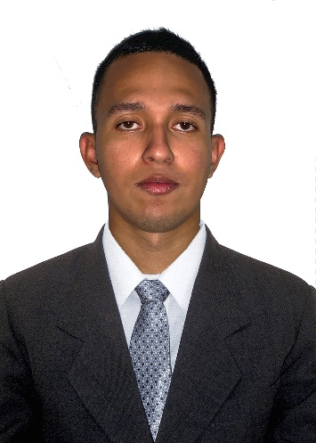

**ID Number**: 1042463868

**Date of Birth:** 09/09/1999

**Email:** [Sebaslozano708@gmail.com](mailto:Sebaslozano708@gmail.com)

**Address:** Calle 55C #6d -11 Altos de la Metro-Soledad

**Phone Number:** 3045788867

Barranquilla-Atlántico

**EDUCATIONAL BACKGROUND:**

**PRIMARY AND HIGH SCHOOL:** Colegio Jesus Maestro F.M.S.D

Soledad – Atlántico (2016)

**OTHERS:** Technical Degree in Accounting SENA (2016) and currently studying Fronted Web Development.

**PROFESSIONAL PROFILE:**

Customer Service representative with extensive experience in Telecommunications company, with broad sense of belonging and competitiveness, always looking forward to bringing the best service to my customers. And my latest experience in a Customer Service position working for an American timeshare resort company, in which I assist customer service-related issues, bringing solutions to customer’s need. This last is a cross-selling service, always looking forward to bringing solutions to customer’s issues and bringing up to their attention the benefits of a possible upgrade of their unit, extra nights, or any add-on We could offer them.

**LABORAL EXPERIENCE:**

**SYKES COLOMBIA S.A.S**: Worked 1 year and 3 months as a customer service representative in a telecommunications campaign, finding out solutions for the wide type of scenarios that included Billing, Basic Troubleshooting and selling lines and features to existing customers.

**SOLVO GLOBAL:** I’ve been working for over 10 months as a customer service agent in the timeshare resort company providing my service in customer service-related tasks, and verifying the vacation packages meet all requirements to be approved as well as earning commissions by selling to customers add-ons.

**IN SUMMARY:**

I am a disciplined and industrious person. I strongly emphasize my responsibility and commitment to always perform and outstanding job, looking forward to mastering the skills I need to carry out my job as efficient as possible. I’m a self-taught English learner and currently I study Fronted Web Development. I have over 2 years o experience working as a customer service representative, which has helped me to level up my multi-tasking skill, willingness to learn and competitiveness.

**PERSONAL REFERENCES:**

**SANDRA BENITEZ:** English Coach at Verizon

**PHONE NUMBER:**  3006595940

**SEBASTIAN SAN JUAN:** Customer service representative

**PHONE NUMBER:**  3127477499

**FAMILY REFERENCES:**

**ALVARO LOZANO:** Security Guard

**PHONE NUMBER:** 3126331674

**KIMBERLY LOZANO:** Accounting Assistant

**PHONE NUMBER:** 3022172620